TC-DISP-029
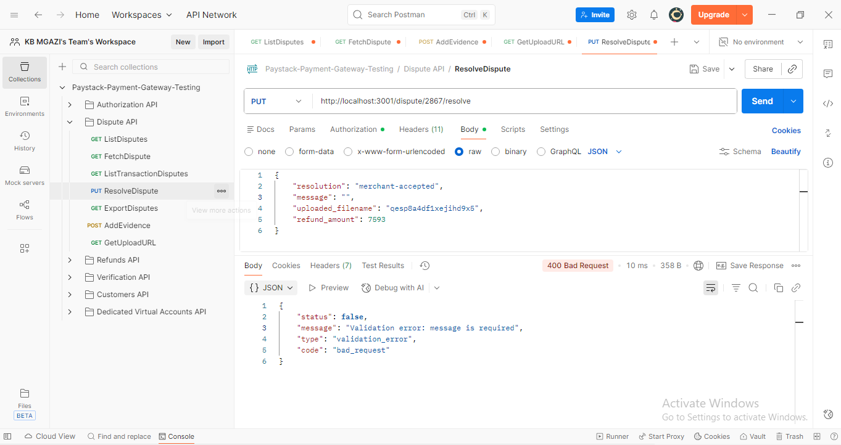
Request:
{
"resolution": "merchant-accepted",
"message": "",
"uploaded_filename": "qesp8a4df1xejihd9x5",
"refund_amount": 7593
}

Response:
{
"status": false,
"message": "Validation error: message is required",
"type": "validation_error",
"code": "bad_request"
}

